Concept Selection
The concepts that were produced from the concept generation process were reduced into 5 medium fidelity concept and 3 high fidelity concepts. These concepts are evaluated through the House of Quality, Pugh charts, AHP, and basic engineering knowledge to determine a final concept. The final concept was chosen as Concept 6, or induction/resistive heating, potentiometer control, composite plate mount, and cylindrical heat exchanger.
Binary Pairwise Comparison Matrix
 | 1 | 2 | 3 | 4 | 5 | 6 | 7 | Total
1. The design can be incorporated into the existing test space. | - | 1 | 1 | 0 | 0 | 1 | 0 | 3
2. The design accounts for the power delivered and geometry of the preheater. | 0 | - | 1 | 0 | 0 | 0 | 0 | 1
3. The test articles will be heated by induction. | 0 | 0 | - | 0 | 0 | 1 | 1 | 2
4. The fluid can be heated to around 2000-2500 K at the outlet of the heat exchanger. | 1 | 1 | 1 | - | 1 | 1 | 1 | 6
5. The design allows for independent temperature control. | 1 | 1 | 1 | 0 | - | 1 | 0 | 4
6. The design monitors physical conditions. | 0 | 1 | 0 | 0 | 0 | - | 0 | 1
7. The design uses materials with high melting temperature and high thermal conductivity. | 1 | 1 | 0 | 0 | 1 | 1 | - | 4
Total (check) | 3 | 5 | 4 | 0 | 2 | 5 | 2 | -

The results from the bitwise comparison matrix were used as scaling factors, or importance weight factors in the House of Quality table.
House of Quality
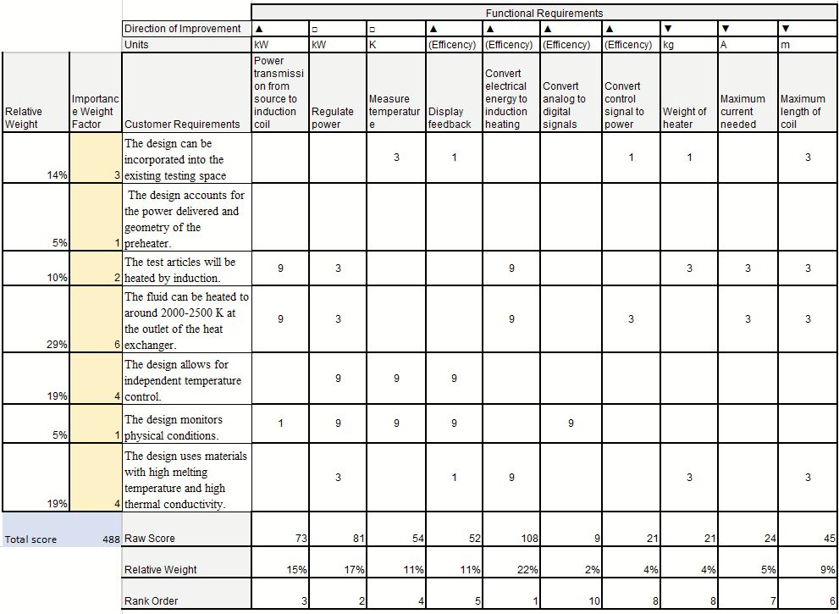
The data from the House of Quality is used to determine what engineering characteristics are most important in the final concept based off customer requirements. This allows for the correct choice of design which reflects what the customer wants, thus including the customer’s voice in the selection process.
First Pugh Chart
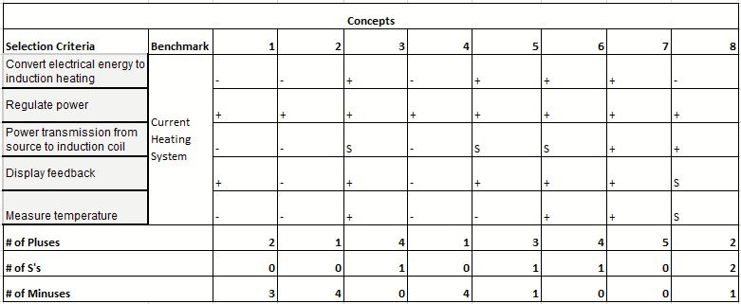
The first Pugh chart data allows the determination of how well the concepts compare to the standard solution to solving the problem. In this case, the standard is the existing design. In the first Pugh chart, the 5 medium fidelity and 3 high fidelity concepts were compared to the benchmark. The result was concepts 1,2,4, and 8 were eliminated. The concept with the most S’s and medium number of pluses to minuses was chosen as the next datum as not make an overly difficult benchmark to reach. Since the concepts were so complex, a medium benchmark that was slightly better than the existing design was deemed appropriate by the team.
Second Pugh Chart
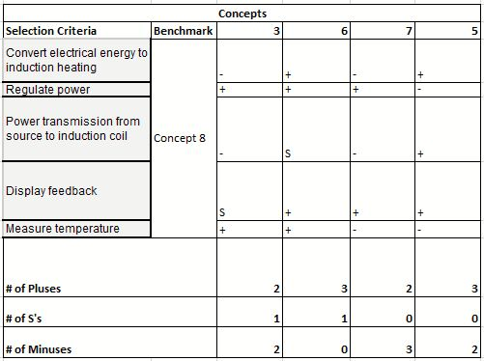
The second Pugh chart features the new datum, Concept 8. It was decided from the second Pugh chart that Concept 6 would work best given the selection criteria because this concept had the highest number of pluses and lowest number of minuses.
AHP
The AHP is a more mathematical selection process. The engineering characteristics for this are taken from the House of Quality, based on the importance weight factor. A pairwise comparison for engineering characteristics is made, with the higher rankings signifying a higher importance in terms of the overall goal of the project. The rows are compared with each column, and based on its importance relative to the column, a ranking value is given. For a given cell value, the corresponding cell across the diagonal will have a reciprocal value based on the nature of the comparison.
AHP criteria comparison matrix
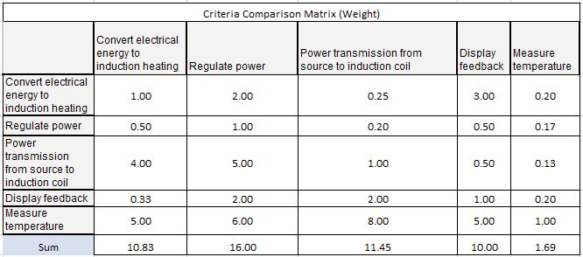
Normalized criteria comparison matrix
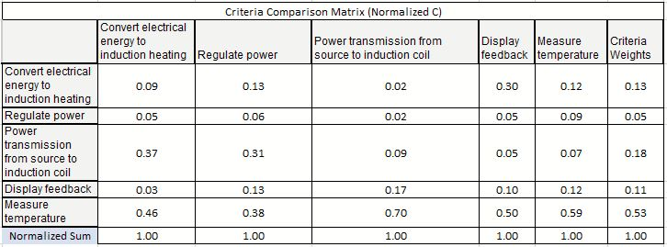
Weighted sum vector and consistency vector
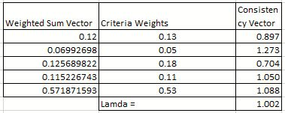
Values used to calculate comparison ratio

